Existing solutions analysis
Prone Positioning
Section 2.2

Isabel Arango
ENGN 1930L Fall 2021

Detailed analysis on existing and emerging products, technologies, services, diagnostics, treatments, and overall approaches regarding prone positioning for patients in the ICU dealing with respiratory failure.

Abstract
After an intricate dissection of relevant methods to asses a range of solutions that have been previously tested, varied conclusions determined abundant existing solutions some which have been successful, some that have failed, and even a couple that are starting to emerge. The goal was identifying the gaps that have not yet been looked into, figure out the unknown areas that require further exploration and gathering of supporting data from past procedures that provide insights to develop a reliable, cost effective and customizable mechanism that sustain ICU patients during prone positioning while reducing pressure injuries. General discoveries where that the range of existing designs that address prone positioning are surprisingly substantial, yet no design has been tailored to successfully avoid the consequences of pressure points in varying body morphologies. Existing design solutions focus more in the shape to properly accommodate the individual, without considering the negative aftermath of staying in the resting position for a long period of time.

Relevant information and background
The prone position has been formally used since 1970 and its main goal was to provide less restriction and open the diaphragm for patients in the ICU to be able to breathe easily and get better oxygenation through the body. The technique is commonly used in patients that have respiratory issues and most are previously in the hospital for some other condition and parallelly develop failing respiratory syndrome (McGurk, 2020.) The treatment focuses on supporting the patient while the lungs recover while achieving an increase in oxygen flow in the blood. Patients with severe hypoxemia are positively impacted with the effective gas exchange in the body and recovery is stimulated (When the patient’s body is turned onto the stomach, during prone position, the larger tissue mass becomes suspended and widens the dorsal chest wall. This way the body acquires a better distribution of pressures throughout the chest and alleviates the lungs from abnormal strains and stress, improving breathing circumstances for the patient and ameliorates risk for severe cases (Kallet, 2016). Relying on previous investigation and evidence of prone position effectiveness, during the COVID pandemic, the method has been applied countless times even more so with the adjunct help of ventilators to combat ventilator-induced injuries to the lung (McGurk, 2020.)

Figure 1
Vertical Pleural Pressure Distribution (Supine + Upright and Prone Positions)
“Representation of vertical pleural pressure (Ppl) distribution from the apex to the bases in the upright position and their respective diminishment in the recumbent supine and prone position. (Kallet, 2016).”

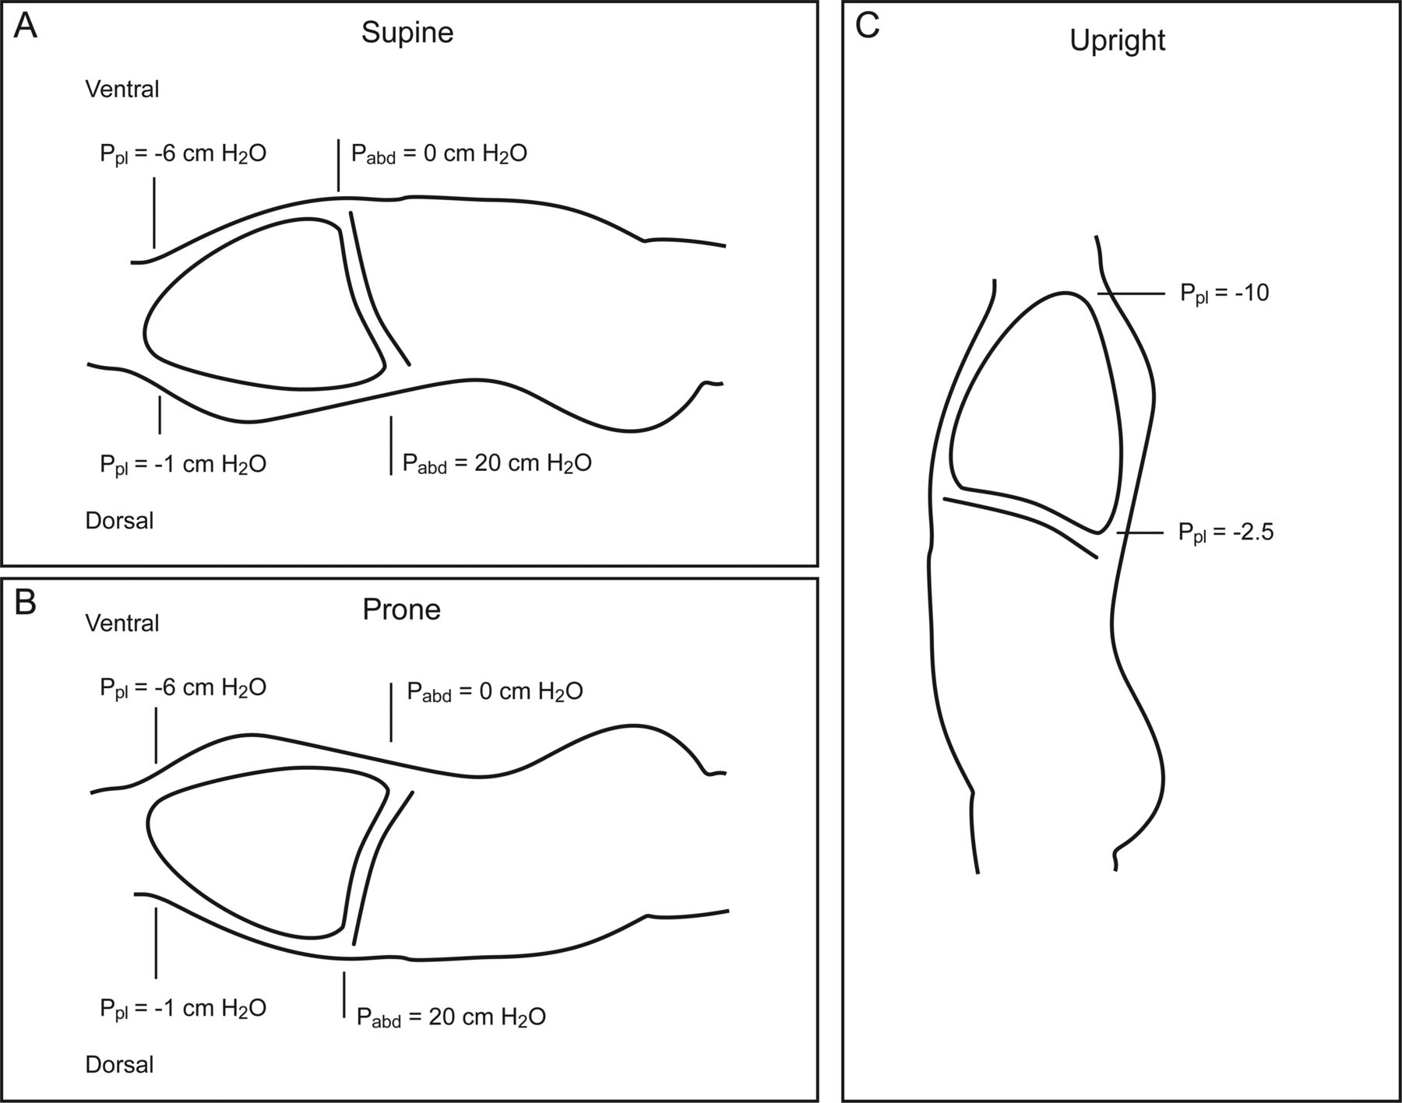
Prone position was discovered and originally used as an effective practice for surgical procedures. It was during these procedures that doctors evidenced the correlation between compression of the abdominal portion of the body and restricted movement of the chest that caused hemodynamic instability. (Van Wicklin, 2020). After a series of trials, the solution was to accommodate the patient in the most organic way possible with the help of padding that supported the chest and pelvic region. Facilitating, therefore, thoracic expansion for better ventilation and breathing. It’s important to state that external padding improved positioning but, paradoxically, it can worsen progression if wrongly supported or used for extended periods of time.

Overview of solution options
Focusing on a high-level description of relevant solutions in the medical field involving development, innovation, use and adaptation of prone positioning methods through medical history. The research emphasizes current methods that work as a foundation for a gap analysis and future refinement of the needs criteria for reducing face tissue pressure involved in prolonged prone position (Yock, Zenios, Mockower, 2015). Prone positioning is a method utilized for various goals. It is the medical term for lying flat on the stomach, contrary to what is known as the supine position or lying on the back (Behring, 2021). During a successful prone position, the patient is faced down, arms extended and secured always at a lower level than the chest. The elbows are flexed and the palms down to maintain alignment of arms and wrists. Finally, the patients head is carefully fixed in a neutral position and should be monitored to have minimal flexion, extension, rotation and pressure in the face tissue (STERIS, 2018). Prone position is used in two main situations. First, to accommodate the patient and provide relief from certain symptoms commonly tied to respiratory conditions. Second, for healthcare specialists that require the patient to be in this position for specific interventions (Wadsworth, 1996). Proning allows the back of the lungs to expand fully with less restriction so it improves breathing and overall oxygen traveling through the body. Existing artifacts used for the technique typically seek to accomplish one of two main goals. (1) Patient accommodation for surgery; (2) Adjusting for relief and oxygenation when dealing with acute respiratory distress syndrome (ARDS). After various indications of its potential to help patients with respiratory failure, the prone position use was increasing exponentially for COVID patients (Langer, 2021).

The COVID-19 pandemic has caused an immense amount of ICU patients to develop acute respiratory distress syndrome (ARDS). “COVID-19 ARDS is diagnosed when someone with a positive COVID PCR result meets the berlin 2012 diagnostic criteria of (1) hypoxaemic respiratory failure; (2) within one week of increasing symptoms; (3) bilateral airspace disease on x-rays (CT); (4) cardiac failure is not the primary cause of the respiratory failure. ARDS develops in 42% of patients presenting with COVID-19 pneumonia and 61-80% of those requiring intensive care with a median time of intubation is 8.5 days. (Gibson, 2020.)”

Faced with this panorama, critical care practice guidelines recommend prone position for adult patients with ARDS and severe COVID-19 infection. As evidenced in the past, these methods are effective for better oxygenation, yet, patients dealing with COVID-19 require intricate care and their high-risk conditions involve extreme finesse during positioning. They also require long periods of resting time which leads to complications associated with patient morbidity that have never been evaluated systemically. Common complications include development of pressure injuries (Pls) on the forehead, eyebrows, chest, pelvis, chin, genitalia, knees, etc. Ocular damage and muscular issues may also occur (Barakat-Johnson, 2020). During an interview considering COVID19 patients in the ICU and their situation with pressure ulcers, Dr. Reena Bhatt stated, “staying in a singular position without moving for more than three hours causes the muscle to start dying.” This means that what once was a pressure injury can translate into musculoskeletal issues and dramatic complications that can be avoidable with the correct implementation of alternative methods. [Bhatt, Reena. (2021, Oct. 05). Personal interview: Prone Positioning for Covid19].

Off course, there are various factors that play a role when developing these complications. There are intrinsic and extrinsic factors that may be involved in the process, and it all comes down to the specific individual; their previous lifestyle, body structure, weight, morphology etc. This indicates the need to calibrate a potential prototype towards a system that takes the individual needs into account, rather than a generalized result. Encountering a solution that encompasses a generic design, but a customizable outcome. Additionally, COVID-19 are commonly subjects to stress during their positioning and are either under anesthetics or muscle relaxants. This means that pain is depressed and pressure receptors can’t achieve their normal defense mechanisms to avoid joint damage or muscle strain. Pressure injuries are considered costly and complicated and are listed as one of the 15 preventable hospital-acquired complications (Lee-Bunker, 2015). Therefore, the importance of analysis existing methods that are being utilized, their effectiveness, their approach and their flaws as a pathway for future innovation and ground to explore.

When, where and how is prone position utilized?

Prone pillows for Surgical Procedures & ARDS treatment
There are many products in market that focus on achieving correct position of the patient to stimulate breathing and lungs Additionally, adjusting patients into certain positions for surgical procedures is really common in all areas of healthcare. There are multiple positions available for different operations and selecting the appropriate one and the artifacts/devices needed to do so is a collaborative process. Preoperative healthcare practitioners, nurses, surgeons and anesthesiologists are involved in the accommodation. “A minimum of four surgical personnel should assist in transferring the patient from the supine to the prone position to provide full support to the patient and avoid injuries to the personnel (AST, 2011).” The prone position is commonly used during procedures that need access to the dorsal part of the patient’s body. Here, there are various devices used to aid in the proper position and intent of pressure distribution. The patient is placed face-down to perform common procedures like spine, neck, brain, vascular, and tendon surgeries. The prone position allows access to the posterior aspects of the individual and increases the capacity and distribution of ventilation and perfusion of the lungs during the operations (STERIS, 2018). There are multiple ways to accommodate a patient into prone position, but the most common pillow is that of the head rest. Most in the market are functionally the same and its proportions and material are generic. Made out of either gel or foam, the head rest supports and protects facial features in the prone position. It contributes stability for the neck and normally includes space for endotracheal tube (Prone Medical). Now on the market one of the most utilized material in the competing brands for prone pillow designs is what’s called raspberry swirl foam. It is optimal for support and latex free. This foam consists of a combination of visco-elastic foam (also called memory foam) and normal foam. This viscoelasticity refers to materials that have both viscous and elastic attributes during deformation. Viscous materials resist shear and strain linearly with stress. Elastics can be stretched and return to their original state (Meyers 1999). This visco-elastic foam has elements of both properties because it’s “a blend of polyurethane foam that was developed for airplane cushions by a NASA contract in 1970 (©Slumber Search Mattresses)”.

Existing Artifacts

Image | Name | Brand | Material | Dimension | Shape | Re-use | Price | Description
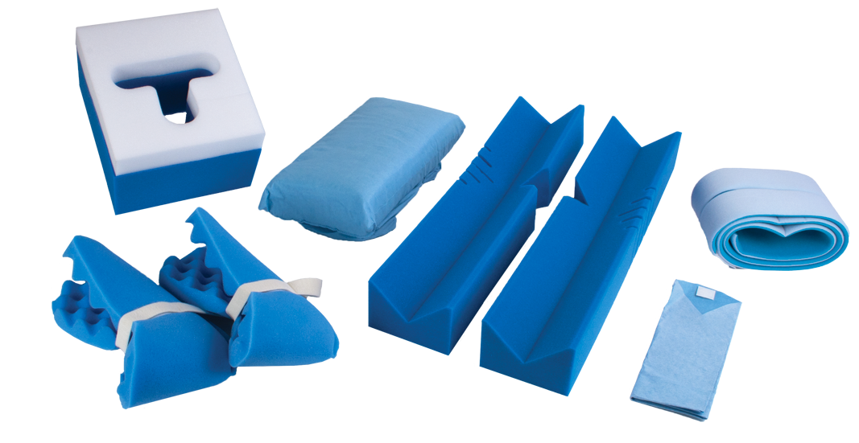 | Procedure kits | Covidien©2015 | raspberry swirl foam | Various | Various | No | From $120 to $550 | Procedural kits for specific OR tables in the market right now. They are designed to provide all the necessary components so that patient positioning is convenient and the overall process reduces set-up time.  Components: 1 Soft-Touch Headrest Pillow 1 Pair, Arm Cradles 1 Chest Pillow 4 Hip & Thigh Pad Covers.
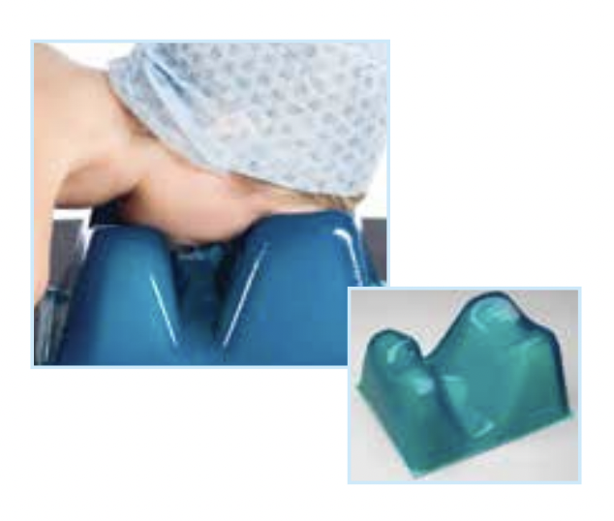 | Oasis Elite™* | Covidien©2015 | Gel | 11”x 9”x 6” | Square  With  indents | Yes | From $226 | The oasis elite is a prone head rest that has been designed to work as an advantage for the operating staff. It is anatomically designed so that the patients head rests down and can have respiratory tubes inserted without complication. The design provides support and stability during the procedure.
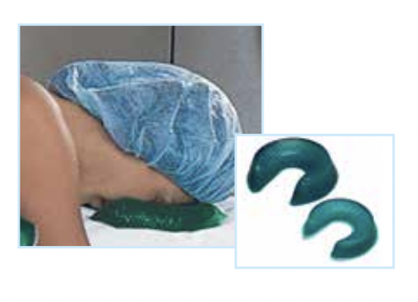 | Open Head Ring | Covidien©2015 | Combination of gel and foam | 5.5" x 1.5" for teens and 8" x 2" & 24" x 21" x 5" for adults | Horse  shoe shaped | Yes | From $87 | This existing design is focused specifically on the head suspension. It has an opening that allows intubation. Commonly used together with additional cushions. foam and gel accommodation devices have been proven effective for achieving successful prone position.
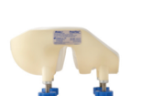 | Protective Helmet | Prone  View | Plastic  & foam cushion insert with four large knobs attached to the helmet offer easier adjustment | Comes in  S, M,L sizes  No dimensions specified | face shaped mask | If sterilized | From $1,061.99 | Helmet-looking mechanism with a mirror base and a cushion insert that can be customizable for the patients use. ProneView can be used on any general surgical table. Easier alignment on to the mirror platform. Larger range of height adjustment for better neutrality of the neck. Surface pressure on the face in the prone position is 29% higher with a non-face-contoured prone positioner than with ProneView. Yet, the product is not for continuous use for more than 8 hours.
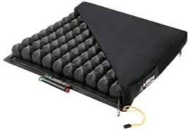 | high Profile Cushion | Roho | lightweight made from neoprene and can be easily patched. Fillable air cavities | 16”x16” | Square  Weighs about 3.8 lbs/1.7 kg | easily cleanable and repairable if needed | From $450 | The Roho cushion was named by Dr. Reena Bhatt as one of the most popular cushions for pronation during the past year. It is composed of five main characteristics that provide quality for its use in the ICU. Its adjustable to shape and weight and might adjust to changes in position over time. Its most common for use of wheelchair patients, but it’s been adopted for COVID patients’ prone position. Provides ventilation due to its air cells that allow air circulation to reach the surface of the skin.
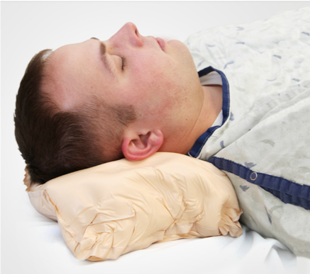 | Fluidized Positioner | Z-Flo ™  ©Mizuho | The cushion is non-powered and it functions with fluid. Moldableadaptable and able to be used with other medical devices. | 21” x19”  26” x 24”  11” x 22”  16” x 30”  25” x 36”  12” x 20”  12” x 20”  16” x 30” | Wide range of sizes for different patient needs | They are for single patient use. | From $130 to $1,305.92 | The Z-Flo positioner is another popular one in the market right now. It has been mostly used in Australia and recent studies have confirmed that the Z-Flo significantly reduced pressure injuries by 87%. Additionally, many Australian ICU nurses stated the positioner had various benefits including how easy it was to mold to the person’s body and that they could create divots to accommodate endotracheal tubes. They offer the possibility of supporting the patient in a comfortable way because of their three-dimensional response that is not strict to any particular shape. They are not subject to gravity.
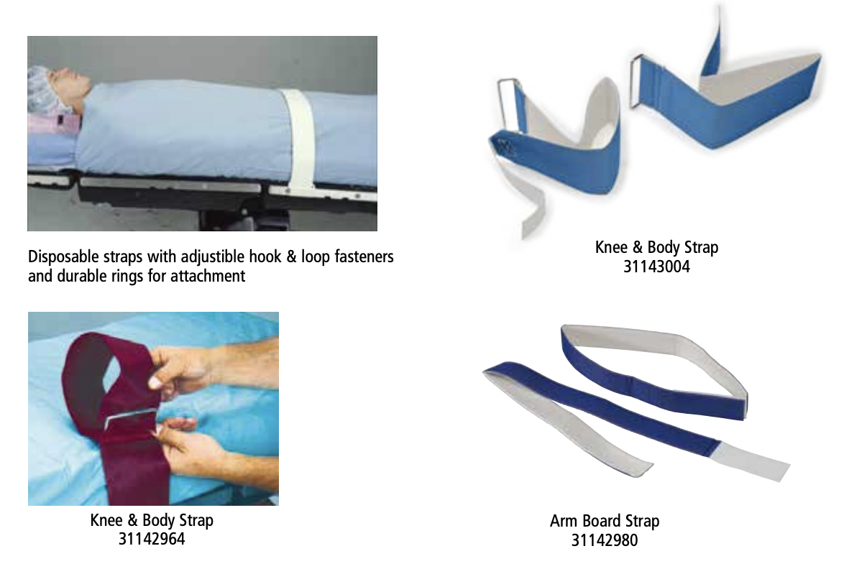 | Position Straps | Covidien | Velcro  Metal hoops  Elastic  Bands Latex free | Knee & Body Strap, 60” x 4”, 6 Knee & Body Strap, 60” x 4”, Arm Board Strap, 26” x 1.5” | Long rectangular elastics | some are reusable if easy to clean and sterilize but most common are disposable. | From $50 to $120 | Head rests are not the only cushions available out there. They normally are complemented with other pillows positioners that keep extremities in place, maintaining the correct skeletal distribution of the patient’s body. Positioning straps are designed for OR tables and gurneys, and can also be adapted to ICU beds, but its more challenging.
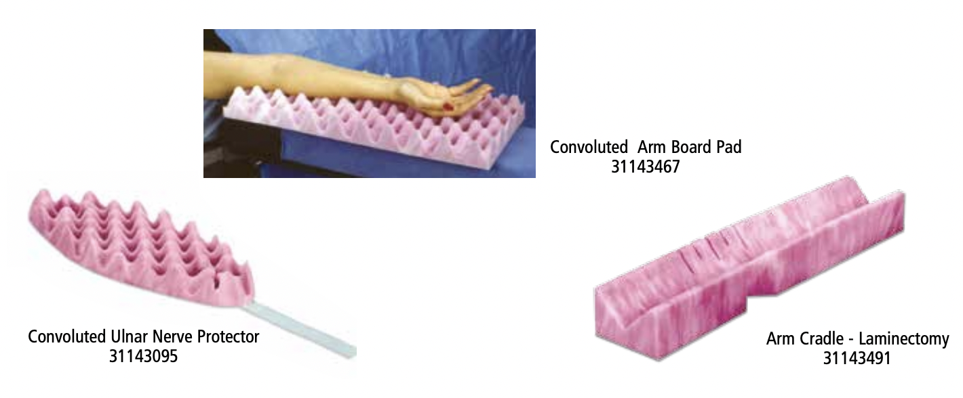 | Extremity Positioners | Devon™ | raspberry swirl foam | Various; commonly generic pieces with further accommodation through Velcro straps | Rectancle and oval shapes with voluminous peaks for breathable surface | Single use | From $500 to $1,600 | Extremity positioners, as stated before are required for extra stability and safety. It is the job of these extra cushions to actually sustain the parts of the patient’s body that are more likely to suffer from pressure points. They are specifically designed to adjust bony prominences and different places of the body that exert a significant amount of pressure in certain areas. They are used in a wide range of procedures.
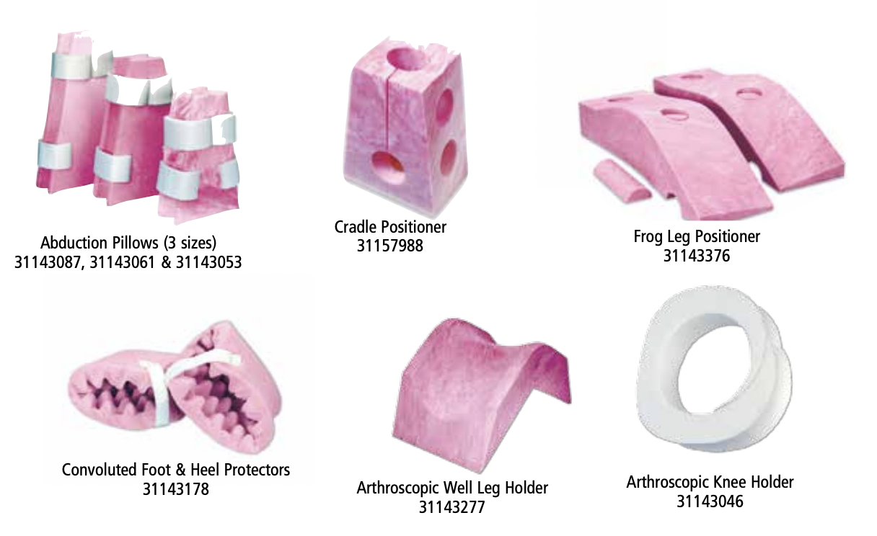 | Lower Extremity positioners | Devon™ | raspberry swirl foam | Small 18” x 12” x 6” Medium, 22” x 15” x 6” Large, 25” x 18”x6” | Various:  Cradle  Oval  donut  Half circle | Single use | From $500 to $1,600 | These positioners provide support and protection for legs, knees, heels and ankles and are designated to achieve correct body alignment during procedures or long resting periods aiding on pressure distribution of lower body.
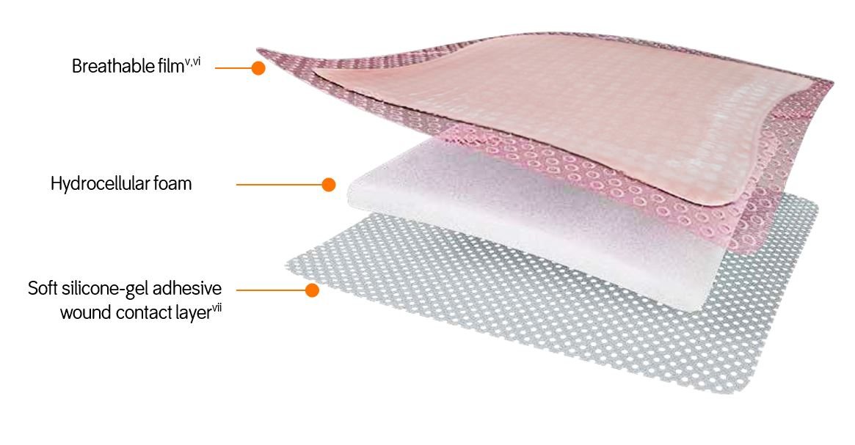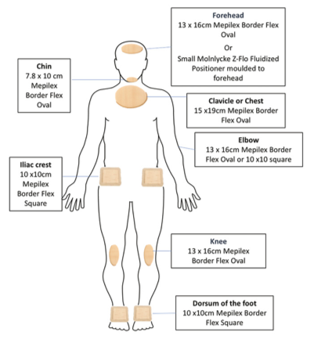 | Prophylactic dressings | Mepilex  Allevyn  Life  Opsite  Flexifix  Duo  DERM | Breathable film  Built in masking layer  Absorbent film  Silicone adhesive contact layer  Hydrocellular foam | 2”x2” & up.  Various shapes and sizes for different parts of the body.  Chin, hips, forehead, bottom, spine, heels, | Various. | Single patient use. They have a wide silicone border which can be lifted and repositioned which may help facilitate  skin inspections | From $6 to $60 | Prophylactic dressings have become a method of research for preventing the development of pressure injuries in patients at risk. They have been successful in supine position, and due to COVID-19 they are staring to be tested for prone position to redistribute pressure and shear. Some have demonstrated a 71% reduction in the onset of sacral pressure ulcers when adding them to standard preventative protocols. Trials are still evolving. They are usually applied over prominent parts of the body and bony structures. Placement of these dressings have to be strictly monitored by the healthcare professionals. It is considered that these prophylactic dressings should be used with other preventative strategies like timed shifts.
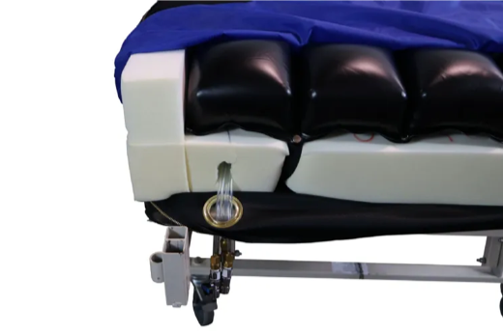 | Comprise reactive air mattresses | Supreme Air™ | 18 independent 8″ deep air cells | Vyvex III™ multi-directional stretch fabric (transfers moisture away from the patient’s skin)  Urethane coated, multi-stretch, low shear, moisture/vapor permeable quilted cover | 42″ x 80″  Large scale mattress to fit in hospital bed or directly embedded into the surgical table. | The cover is low shear, washable, anti-microbial, fluid-resistant, and fire retardant. | From $2,000 up | There are a couple of medical mattress designs that have been commonly used in Australia during the COVID-19 pandemic. There is a variety of designs from all over the world consisting of comprise reactive air also known as low air loss mattresses or alternating/dynamic mattresses. These have increased adoption in ICU’s over the world due to their effectiveness to accommodate patients. The mattress requires no pump and uses patented technology to heal stage 1 to 4 wounds. These mechanisms provide low air pressure to reduce contact pressure between the skin and the surfaces. They work in immersion by evenly distributing weight in the surface area. The mattress is made up of a series of air cells that inflate and deflate periodically, relieving any pressure applied to the tissue during extended prone time (Barakat-Johnson, 2020).

Utilization solution profile
How are the solutions used in clinical practice, by whom and where?
Thee use of prone positioning methods are exponentially increasing because of the current circumstances and even though it can be really effective, getting the patient into the position is a challenge that requires an adequate number of personnel. As mentioned before, there is a need of at least four people involved in the process, several devices and additional equipment, more so to accommodate bigger patients. STERIS healthcare professionals indicate a series of guidelines that consider successful, safe and dignified patient positioning. Professionals must ensure all prominent parts of the body are supported, ensure breasts, abdomen and genitals are free from excessive pressure, padding the shins, always using a head positioner while preventing direct pressure in the eyes and keeping it in a neutral position with natural alignment to the body. Additionally, for safety measures there always needs to be a gurney ready in case a cardiopulmonary resuscitation is needed. Finally, the professional must always protect the patient’s dignity in case any exposure has to be done (STERIS, 2018).

Emerging solution profile
New products, procedures, prevention products, treatments and management of pressure ulcers are likely to develop within the solution landscape in the years to come. Due to its rising urgency there is a visible need to address the issue. Aforesaid, there are multiple solutions to accurately position the patient and reduce pressure ulcers, yet the gap clearly lies in their effectiveness to achieve the later goal. Presented in figure 3 are existing types of solutions, their properties and characteristics that lead to the final conclusion and revision of the original need statement below.

Figure 3
Solution categorization 2.2.1
(Bio design: Innovating Medical Technologies, Pg. 134) ( NICE Clinical Guidelines, No. 179.)

Type of Solution | Kind | Properties/characteristics
Low-tech (non-powered) | Standard Foam | Compression Force Deflective (CFD)  Set Resistance  Anti-Microbial  Breathability
 | Alternative foam  (Raspberry swirl) | Compression Force Deflective (CFD)  Set Resistance  Anti-Microbial  Breathability  Easily restores shape  Elasticity
 | Gel-filled | gel-infused memory foam  pressure-relieving support  addition of gel adds springiness  Heat retention  Higher price
 | Fiber-filled | fluffing is necessary to maintain loft  stuffed with polyester fiber or puffball  cooling effect when sleeping  compress or flatten
 | Air-filled mattresses | better blood circulation and pressure relief  have hundreds of air holes  allow for tiny amounts of air to escape “air leak” patient feels like floating  Maintains cool temperature  easier to use + can deflate
 | Bead-filled mattresses | moldable and malleable  conform perfectly to space  breathable  heavy  not sterilizable
High-tech support surfaces | Alternating-pressure mattresses | pressure redistribution to stimulate blood flow  air cells on the mattress inflate and deflate  adjustable cycle time  needs pump
 | Air-fluid beds | warm air under pressure  small ceramic beads in motion  simulate the movement of fluid  body weight is evenly distributed  calls for frequent repositioning of the patient
 | Low-air-loss beds | multiple inflatable air tubes  alternately inflate and deflate  can be used for both prevention and treatment  well suited for immobilized patients  requires a pump
Other support surfaces | Turning beds | manual repositioning of the patient, or by motor driven turning and tilting
 | Wheelchair cushions | conforming cushions that reduce contact pressures by increasing surface area in contact, or mechanical cushions which alternate pressure.
 | Limb protectors | Cushions that protect bony prominences  Standard foam

Conclusion & Gaps in the landscape of existing solutions 2.2.2
The efficacy of current solutions seems to be the biggest gap in the prone pillow market. Today, 2.5 million patients per year are affected by pressure ulcers developed in their hospital stays and there is no design available that is directly dealing with this increasing number. The gap in the landscape is not a lack of alternatives, it’s a lack of addressing the issue in its entirety. It’s not enough to band-aid the problem when there are so many patients facing these side effects of prone positioning. There’s no point in offering a solution to a problem that parallelly creates another one. This leads to a reflection on the initial need statement. In conclusion, looking at the design challenge as a mere task to re-design the prone pillow is a limited mistake. There are definitely numerous approximations to reduce the pressure points and ulcer appearances in this specific position and the innovation can precisely be in how the patient is accommodated rather than with what. Additionally, the previous statement declared the “population” to be all ICU patients requiring prone position, but most existing solutions work effectively for patients in prone during 8 to 10 hours. The issue arises when the patient is in the resting position for more than 12 hours even as extensive as various days. These are specific conditions for patients dealing with ARDS from COVID-19. This means it is accurate to narrow down the need statement population to COVID-19 patients with respiratory failure.
The original need statement aimed to develop a reliable, cost effective and customizable mechanism that supported ICU patients during prone positioning while reducing pressure injuries. General discoveries where that the range of existing designs that address prone positioning are surprisingly substantial, yet no design has been tailored to successfully avoid the consequences of pressure points in varying body morphologies. Existing design solutions focus more in the shape to properly accommodate the individual, without considering the negative aftermath of staying in the resting position for a long period of time. The revision of the need statement should also contain a valuable factor that precisely affects the overall appearance of the condition; exposure time.

The final revised need statement might look something like:

“Need for a customizable mechanism to easily accommodate COVID-19 patients in the ICU into prone position for extended periods of time, while reducing pressure ulcers, facial edemas, ocular complications, and nerve injuries during the process.”

Bibliography

P. Yock, S. Z. (2015). Biodesign (Innovating Medical Technologies) Second Edition. United Kingdom: Cambridge University Press.

Association, A. L. (n.d.). ARDS Treatment and Recovery. Retrieved from https://www.lung.org/lung-health-diseases/lung-disease-lookup/ards/ards-treatment-and-recovery

Butterworth IV J.F., &. M. (2018). Anesthesia for neurosurgery (Vol. 6e). Morgan & Mikhail's Clinical Anesthesiology, 6e. McGraw Hill.

Behring, S. “Prone Position: What It Is and Why It's Used.” Healthline, Healthline Media, 13 July 2021, https://www.healthline.com/health/lung-cancer/prone-position.

VAN Wicklin S. A. (2020). Systematic Review and Meta-Analysis of Prone Position on Intraocular Pressure in Adults Undergoing Surgery. International journal of spine surgery, 14(2), 195–208. https://doi.org/10.14444/7029

Kallet, R. H. (2015). A Comprehensive Review of Prone Position in ARDS. Respiratory Care, Vol.60 Issue 11.

STERIS Healthcare. (2018, December 11). Retrieved from The Complete Guide to Patient Positioning: https://www.steris.com/healthcare/knowledge-center/surgical-equipment/complete-guide-to-patient-positioning

WADSWORTH, R., ANDERTON, J.M. and VOHRA, A. (1996), The effect of four different surgical prone positions on cardiovascular parameters in healthy volunteers. Anaesthesia, 51: 819-822. https://doi.org/10.1111/j.1365-2044.1996.tb12608.x

Langer, T., Brioni, M., Guzzardella, A. et al. Prone position in intubated, mechanically ventilated patients with COVID-19: a multi-centric study of more than 1000 patients. Crit Care 25, 128 (2021). https://doi.org/10.1186/s13054-021-03552-2

University of Miami Health System. (n.d.). Retrieved from Hemodynamic inestability: https://umiamihealth.org/treatments-and-services/pediatrics/critical-care-(pediatrics)/hemodynamic-instability

Gibson, P. G., Qin, L., & Puah, S. H. (2020). COVID-19 acute respiratory distress syndrome (ARDS): clinical features and differences from typical pre-COVID-19 ARDS. The Medical journal of Australia, 213(2), 54–56.e1. https://doi.org/10.5694/mja2.50674

Daniel Lee John Bunker, Michael Thomson, "Chin Necrosis as a Consequence of Prone Positioning in the Intensive Care Unit", Case Reports in Medicine, vol. 2015, Article ID 762956, 3 pages, 2015. https://doi.org/10.1155/2015/762956

Westby, M. J., Dumville, J. C., Soares, M. O., Stubbs, N., & Norman, G. (2017). Dressings and topical agents for treating pressure ulcers. The Cochrane database of systematic reviews, 6(6), CD011947. https://doi.org/10.1002/14651858.CD011947.pub2

McGurk, K, Riveros, T, Johnson, N, Dyer, S. A primer on proning in the emergency department. JACEN Open. 2020; 1: 1703– 1708. https://doi.org/10.1002/emp2.12175

National Clinical Guideline Centre (UK). The Prevention and Management of Pressure Ulcers in Primary and Secondary Care. London: National Institute for Health and Care Excellence (UK); 2014 Apr. (NICE Clinical Guidelines, No. 179.) 12, Pressure redistributing devices. Available from: https://www.ncbi.nlm.nih.gov/books/NBK333135/

Barakat-Johnson M et al. Pressure injury prevention for COVID-19 patients in a prone position. Wound Practice and Research 2020; 28(2):50-57 https://doi.org/10.33235/wpr.28.2.50-57

AST, A. B. (2011, April 1). Association of Surgical Technologists. Retrieved from Standards of Practice for Surgical Positioning: https://www.ast.org/uploadedFiles/Main_Site/Content/About_Us/Standard%20Surgical%20Positioning.pdf

Challoner, T., Vesel, T., Dosanjh, A., & Kok, K. (2021). The risk of pressure ulcers in a proned COVID population. The surgeon : journal of the Royal Colleges of Surgeons of Edinburgh and Ireland, S1479-666X(21)00121-9. Advance online publication. https://doi.org/10.1016/j.surge.2021.07.001

Meyers and Chawla (1999): "Mechanical Behavior of Materials", 98-103.

Chen, Chun-Yu MD^{a,b}; Chiang, I-Han MDª; Ou, Kuang-Ling MD, PhDª; Chiu, Yu-Lung PhD^{c,d}; Liu, Hung-Hui MDª; Chang, Chun-Kai MDª; Wu, Chien-Ju MDª; Chu, Tzi-Shiang MDª; Hsu, Kuo-Feng MDª; Huang, Dun-Wei MDª; Tzeng, Yuan-Sheng MD^{a,∗} Surgical treatment and strategy in patients with pressure sores, Medicine: October 30, 2020 - Volume 99 - Issue 44 - p e23022 doi: 10.1097/MD.0000000000023022

abnormal or unstable blood pressure, which can cause inadequate blood flow (UHealth, 2021).

